EXPERIMENT 6

Aim
Simulation of Open Shortest Path First (OSPF)

Prerequisite
Nil

Outcome
To impart knowledge of Computer Networking Technology

Theory
Open Shortest Path First (OSPF) is an Interior Gateway Protocol (IGP) that is used to route data within a single autonomous system (AS). OSPF is a link-state protocol, which means that it maintains a database of the topology of the network. This database is used to calculate the shortest path between any two nodes in the network. OSPF is a classless protocol, which means that it does not distinguish between different classes of IP addresses. This makes OSPF a good choice for networks that use a variety of IP address classes. OSPF is a reliable and scalable protocol that is widely used in enterprise networks.
OSPF uses a flooding algorithm to distribute routing information throughout the network. When a router joins an OSPF network, it sends a Hello packet to all of its neighbors. The Hello packet contains information about the router's interface, such as its IP address and the OSPF version that it supports. If a neighbor responds to the Hello packet, then the two routers form a neighbor relationship. Once a neighbor relationship is established, the routers can exchange routing information.
OSPF uses a link-state database to store information about the topology of the network. The link-state database is a collection of link-state advertisements (LSAs). Each LSA contains information about a single link, such as the link's IP address, the link's cost, and the link's state. The link-state database is used to calculate the shortest path between any two nodes in the network.
OSPF uses a Dijkstra algorithm to calculate the shortest path between any two nodes in the network. The Dijkstra algorithm is a shortest path algorithm that is used to find the shortest path between a source node and a destination node in a graph. The Dijkstra algorithm works by building a tree of nodes, where each node in the tree represents a possible path from the source node to the destination node. The algorithm starts by adding the source node to the tree. Then, it adds the node with the lowest cost to the tree. The algorithm continues to add nodes to the tree until the destination node is reached.
OSPF is a reliable and scalable protocol that is widely used in enterprise networks. OSPF is a link-state protocol that maintains a database of the topology of the network. This database is used to calculate the shortest path between any two nodes in the network. OSPF is a classless protocol that does not distinguish between different classes of IP addresses. This makes OSPF a good choice for networks that use a variety of IP address classes. OSPF is a reliable and scalable protocol that is widely used in enterprise networks.

Procedure:
- Open Cisco Packet Tracer and simulate the sample topologies for OSPF.
- Perform Necessary Operation on Switch to create and configure OSPF.
- Check the connectivity between the devices.

Steps:
- Topology Setup: Create your network topology in Packet Tracer with routers and connections.
- Router Configuration: Assign IP addresses and default gateways to the interfaces of your routers.
- OSPF Configuration: Activate OSPF routing on your routers and set unique process ID for each OSPF instance. Also, define the network and area for OSPF.
- Implement OSPF Single Area Network: Configure the implementation of OSPF in the Network.
- Verify OSPF Implementation: Use show commands to verify whether the implementation of OSPF is done correctly or not.

Output:
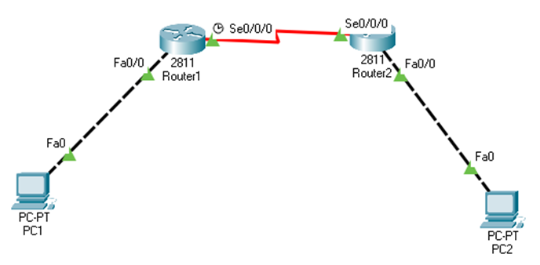

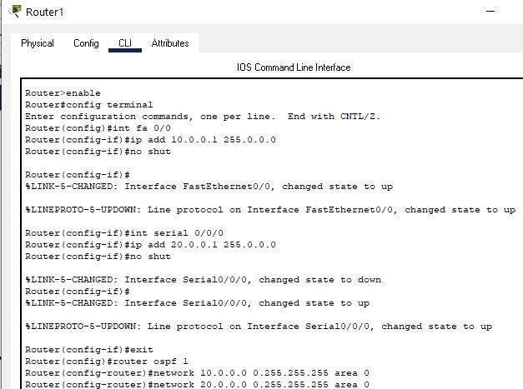

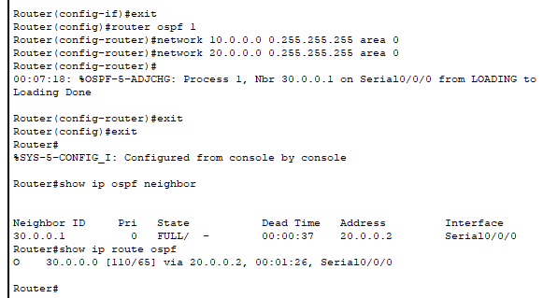

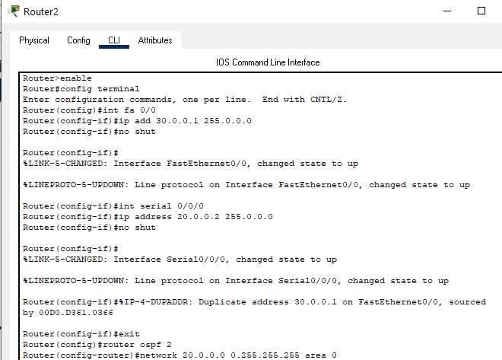
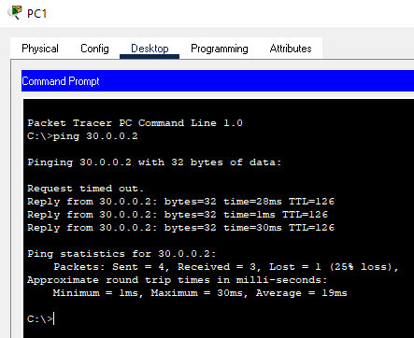
Observation & Learning
In the OSPF implementation experiment in Cisco Packet Tracer, we observed that OSPF efficiently established dynamic routing, exchanged routing information, and maintained network connectivity. We learned the importance of consistent process IDs and accurate network address specification for OSPF. This experiment highlighted OSPF's role in automating routing processes, ensuring efficient data transmission, and adapting to network changes, underscoring its significance in creating robust networks.

Conclusion
In summary, the OSPF implementation experiment in Cisco Packet Tracer showcased OSPF's efficiency in dynamic routing, reinforcing the significance of process ID consistency and accurate network address configuration. It underscored OSPF's crucial role in building resilient and adaptable network infrastructures.

